CINEFY: Movie booking Application

# Submitted by: - Parth Parashar (PSU ID: - 923928157)

## Other Project Partners: - Pragati Rathore and Kirtan Patel

**GITHUB repository Links: -**

<https://github.com/parasharparth/cinefy-backend>

<https://github.com/parasharparth/cinefy-frontend>

**The link for my presentation is: -**

<https://youtu.be/xhggLGwXZfU>

**I tried reaching out to the other members of the team for preparing a group presentation but there wasn’t any response from any of them which is why I had to prepare and submit my part of the project presentation in this link.**

This document consists of the following topics: -

1. Tech Stack
2. Architecture followed
3. Running the Project
4. My Project Journal
5. Overall Experience
6. Snapshots of the actual project
7. Improvements in the project

**Tech Stack: -**

The project tech stack which was decided upon in the beginning of the project included: -

Backend- Spring-boot (Java) and Docker

Database used- POSTGRE SQL

Front-end- React JS.

**Architecture followed: -**

The architecture being followed for the project is: -

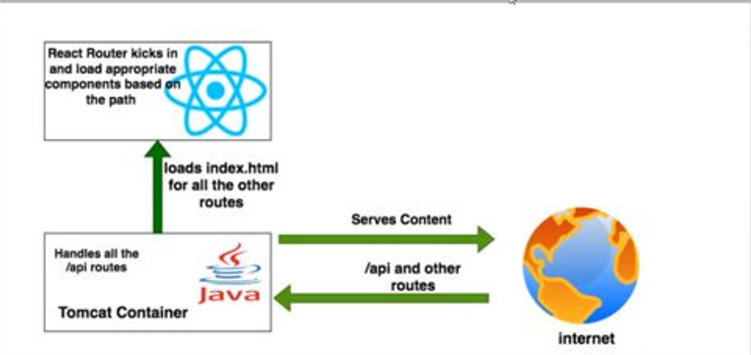

From this picture, instead of tomcat container, we have Docker container.

Instead of internet, we will have POSTGRE SQL.

Also, the routing of the data will be done using the java containers, which in case of spring-boot are the microservices which will be called by both react and POSTGRE SQL.

For the data coming from the POSTGRE, different set of microservices will be used and for the data coming to and from the REACT microservices, different set of API(s) will be used. The docker will act as a container for encapsulating all the activities for backend.

**Running the project: -**

For starting the project, we need to start the backend first. For starting the backend, there are three components which need to be started in the given order: -

1. Docker
2. POSTGRE SQL Server
3. Java Sprint-boot application using maven scripts

For starting the spring-boot project, open the project in intellJ or other editor such as eclipse and then click on the run profiles sections where we have to create the run profile: -

$JAVA_HOME/bin/javac -java backend-SNAPSHOT-0.0.1.jar

Click on run and the project will start and will create the required microservices will be created.

For starting the front-end, we need to get the project from the github repository in a code editor such as VSCode and then in the integrated terminated, run the following commands: -

Npm build

Npm build run

Npm start

Npm start will prepare the react application and start it on the front-end which in this case is a web-browser.

**MY PROJECT JOURNAL: - (Detailing my work and contribution to the project)**

While the discussions around the project were there from the beginning of the quarter, it all started with the formation of teams.

After the team was selected, it was week-2 when we started discussing and working on the project

**Week of 24 April – 1 May: - (Called week-1)**

In week 2, we had a team meeting where we pondered over the topic of the project. There was a plethora of suggestions which were put across the board ranging from a e-commerce marketplace to a booking system.

Since we all are movie fanatics, we decided to make our project on a movie ticket booking system. This can further be extended to have other booking systems as well.

In this week, we discussed what tech stack we are going to use. Since it is a full-stack project, we decided to use react + Java spring-boot + POSTGRE SQL for the project.

I was always curious as to how different java frameworks worked in conjunction with the integrated front-end where both use microservices to render the different parts of the web application. Because of this, I decided to take the java sprint-boot part of the project. Kirtan took up the front-end part of the project and Pragati decided to take up the devops part.

We also decided which features would be included in the web application. The features which were agreed upon in the first meeting were: -

1. Login Page
2. Home Page
3. Booking Page
4. Payment Page
5. About us Page

Since the Spring-boot framework was new to me, I did some digging as to what I need to have in-place for succeeding in making microservices in Spring-boot.

Some of the materials which I studied included (but were not limited to) are: -

<https://spring.io/projects/spring-boot>

<https://www.javatpoint.com/spring-boot-tutorial>

<https://www.baeldung.com/spring-boot>

**Week-2**

During this week of the project, I decided to make the skeleton projects for both front-end and back-end. For back-end, I did so by using Spring initializer pack from eclipse which creates the basic file structure containing the following files: -

1)src (main + test)

2) pom.xml

3) dependency graph and folder

4) .mvn

For Front-end, I created the skeleton project by using the React npx command.

The command for the same is given below: -

Npx create-react-app cinefy-frontend

This creates the skeleton react application.

After the skeleton project was created, I wanted to put the projects in a github repository so that every member of the team can start working on the project as soon as possible. I tried to make folders in the github repository for front-end and back-end and then tried to push the skeleton projects (both front-end and back-end) into the github repository. The projects did push in the github repository. But there was an issue, none of the project properties were being recognised by the GIT command prompt. This is because both projects were from different structural configurations. This meant that it was futile to put both of them in the same repository and expect them to work.

I did try a few other things over the next couple of days to overcome this situation, but it did not improve. So, in the end, I decided to put both front-end and back-end in different repositories for the sake of simplicity and getting the project started.

After this, I did start working on the featured movie page for which I created the MVC classes (Domain, controller) along with the JPA repository class for getting data from the table. The domain which maps to the JPA repository element was also created.

I also decided to put the different versions of HTTP errors as user defined classes and put in a couple of error classes as well. I did this because I could modify the message according to out convenience and not print the default error message as they do not appear good for user interaction. This week was a smooth sailing for the project as there was some form of communication as well as there was the work was being finished at a very fast pace.

**Week-3: -**

During this week, I picked up on the remaining work for the featured movie page by creating the “service” methods to be called in the controller to pass the data effectively. Tested the service with the help of test data and postman.

The next thing which I did in this week was to create the about us page and its domain. I created the classes containing JPA methods to handle the About page.

All this was useful as we wanted to test out the About us page.

Apart from this, I also created the microservice for the booking page. This included the domains (for mapping elements), JPA repository and model. New HTTP exceptions were added as well. Simultaneously, I also prepared the services for login page as well. The domains were added for both these pages, and I waited for the front-end to catch up with the back-end at this point.

I wanted to test these but that could not happen because the database was running behind from the devops end and I ended up testing these services using dummy data and postman again so as to make sure that all the bases are covered.

Then after this, I started working on the Home - page and created the domains for it in this week.

**Week-4: -**

Now, for this week, I had the task of completing the Home page. I completed the home page aby creating all the classes which were required to test the functionality of the home page.

I had an issue with the annotation. Since I had modelled it using class instead of inferface, I had to write my own getter and setter along with the other hashing functions for the page to get the data from the database. It included the functions such as findall() as well which were used to get the data from the repository to the controller. It did work out nicely in the end.

At this point in time in the project. I wanted us to test all the functionality of the project by integrating the front-end and back-end which was the task of the devops person but for some reason, when I tried to contact the other team members, nobody responded. The meeting which was mandatory for the project never happened. To test the code which I had written, I again inserted dummy data into the database and tested the microservice of home page using postman.

I tested various types of data for the application so that I can simulate the various input types.

I was getting increasingly worried about the devops part because I had no idea as to what was being done in the devops part. I wanted the project to work properly so I started integrating small snippets of code for the facilitation of the smooth data transfer from front-end to back-end. JSON object was something that we had agreed upon to use as a standard for data transfer so I started introducing code which could handle all the possibilities. I introduced the utility package and conversions package.

The use of the utility package is to improve the mappings and also implement the container for the integration of docker. The classes boxed and unboxed objects is to cover the possibilities of docker being boxed or unboxed. I did not write code in it as it could lead to confusion for the devops person. But I did create a proper structure in the project so that it could help in understanding better. Same goes for the conversions.

**Week-5**

The utility package which I created in the last week was extended to include the conversions of java arrays to list, hashmap and double list to hashmap as well. This could be used to store the integer or JSON objects. The code can be modified for the data type which needs to go.

So the day of the submission when we had to submit the draft (1st June), I tried to reach out and discuss as to what we need to do, there seemed to be some sort of confusion about the architecture of the project with the devops person, so the devops person changed the architecture and code of the project in a way that my java part looked redundant. I tried to reason with them but nobody seemed to listen to me. I don’t understand where it went wrong, but the communication seemed off between devops and other people. The devops person completey ignore the java code which I had written, questioned the code and then simply decided to make modifications as and when desired. The project looked completely different than it should have been. The architecture is lost, the use of java minimal and the use of microservices was just for the sake of it. I am still unable to understand where it went wrong.

This is when I decided to write a mail to professor seeking help with whom I had a zoom meeting and sorted things out from my end.

I have committed the code to the main branch whereas the database code which I wrote for database connectivity is still present in my dev branch on git.

These unfortunate, events in my humble opinion, led to the downfall of the project and after this, the communication completely stopped. Even the database seems to have only a single table which is a far cry from the multiple table architecture we had agreed upon in the beginning.

But still, I decided to chip in and help the other team members with the front-end and connectivity part. I still improved the UI on the About us page by modifying the code for the same.

There were buttons present for the user to navigate to the booking page from the home page and information bet transferred onto the booking page regarding the movie selection from the home page.

I implemented the method for transferring the information and navigating to the correct page on button link. I used <link> tag for the same.

I also implemented the movie list to be displayed on the booking page.

I then implemented the accessibility code in CSS for the about us page.

But I was very disappointed by the fact that the original architecture that we were supposed to use was changed at the very last hour without consulting or informing me which left me in a place where a lot of the code which I wrote became non-usable in the context of the project. Since I was primarily coding in java, it looked bad on my part. What made it even worse was the fact that there was no real effort to make use of the java code when all I was thinking was how the project could have good amounts of equal contributions from everyone.

Even after multiple reminders and tries to reach out to the team, the communication was not there which led to this situation.

**OVERALL EXPERIENCE**

My overall experience in the project was that I was able to learn a lot about full-stack development and how it is an entirely team dependent thing. The need for effective communication in the team and proactive code integration is a must for the development of the project. Team effort and environment is of utmost importance. But I got to learn a lot in terms of the technical knowledge. I was able to learn a completely new framework in terms of spring-boot. It definitely made me aware of the advanced java practices like the use of spring annotations, the use of pom.xml for dependency, the use of dependency injections to make use of unrelated classes is something that would definitely help me write java code more compactly and efficiently. I was also able to learn the importance of react microservices which if connected properly with the backend can render an application flawlessly and is so easy to debug. Even if one microservice malfunctions, everything does not come crashing down. I came to understand this when my home page domain and controller were continuously throwing errors which mostly included the dependency errors relating to missing dependencies in the pom.xml. But I was still able to run the other components without them failing at the same time. This means that when implemented properly, microservices are a real boon. The distribution of work also becomes easy as no one is really dependent on the other.

What I really loved about the project was the even after so many hurdles, I was able to grow as a person who now appreciates the importance of good team environments.

While in the end, I was disappointed with how my work was not in proper use and the architecture was different, it was still a worthwhile experience.

**SNAPSHOTS OF THE PROJECT: -**

Docker up and running: -





Final Data available in DB: -



Backend + Final Database



UI: -









**IMPROVEMENTS IN THE PROJECT: -**

1. **The major improvement which can be made in the project is the proper use of java backend which can actually make this as a proper microservice based web application.**
2. **Another major improvement in my opinion would be the proper react based UI.**

**FRONTEND COMMIT(S): -**

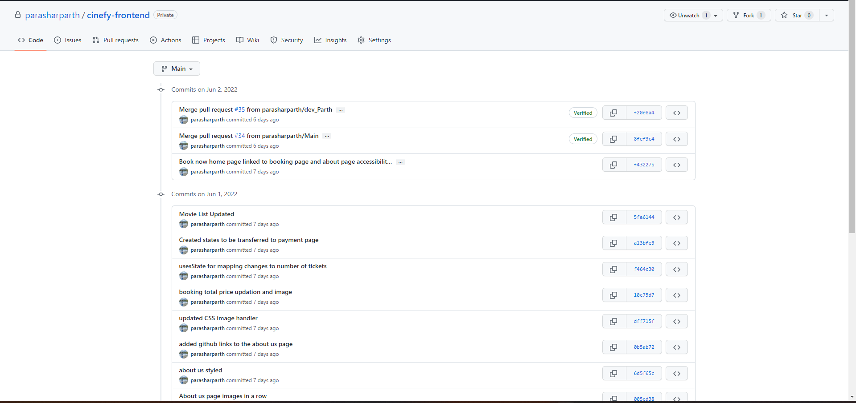

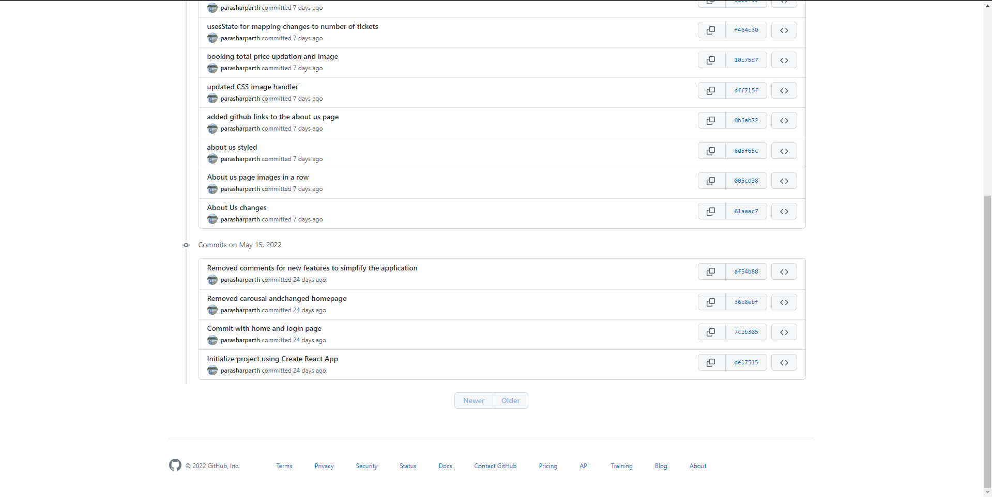

**BACKEND COMMITS: -**

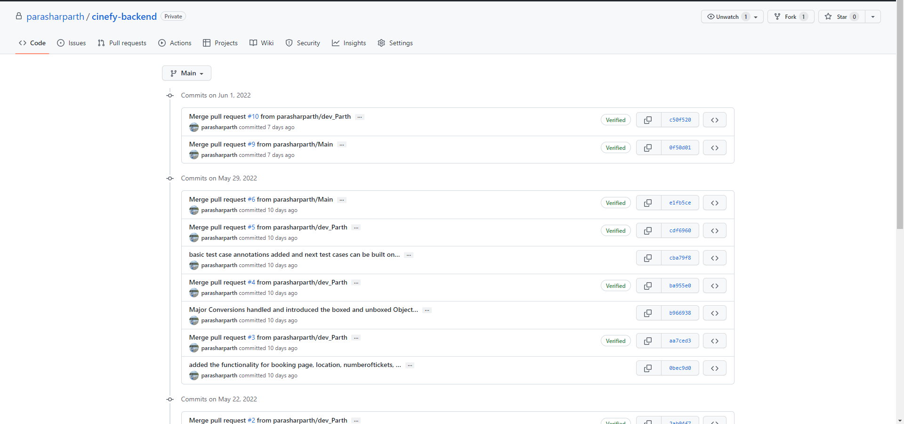

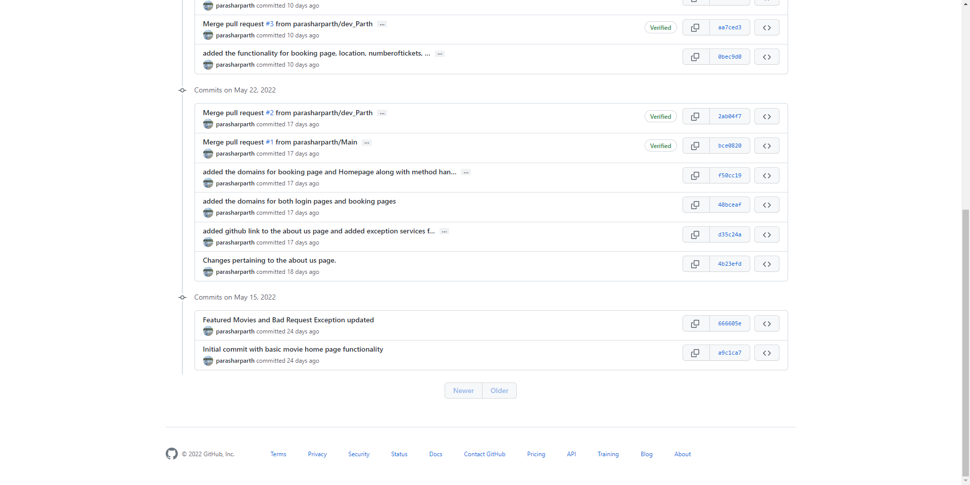

**NOTE: -**

**The backend commit is some commits ahead because I had prepared the db connectivity code which I had not committed because the devops person had prepared a different code for db connectivity. Not sure how it works, I have not committed it to the main branch but I have committed it to my dev_parth branch for the professor to look at just in case it is needed to reference.**

**CODE SNIPPETS: -**

Backend structure: -

